**Rufugees management system**

**Introduction to Refugee Management System**

A **Refugee Management System** is a comprehensive database and software solution designed to effectively manage information related to refugees. This system plays a vital role in organizing, storing, and retrieving essential data about refugees, their sponsors, employment, health records, and other relevant details. The goal is to provide streamlined and efficient management to support refugees' integration into society while ensuring their well-being and legal compliance.

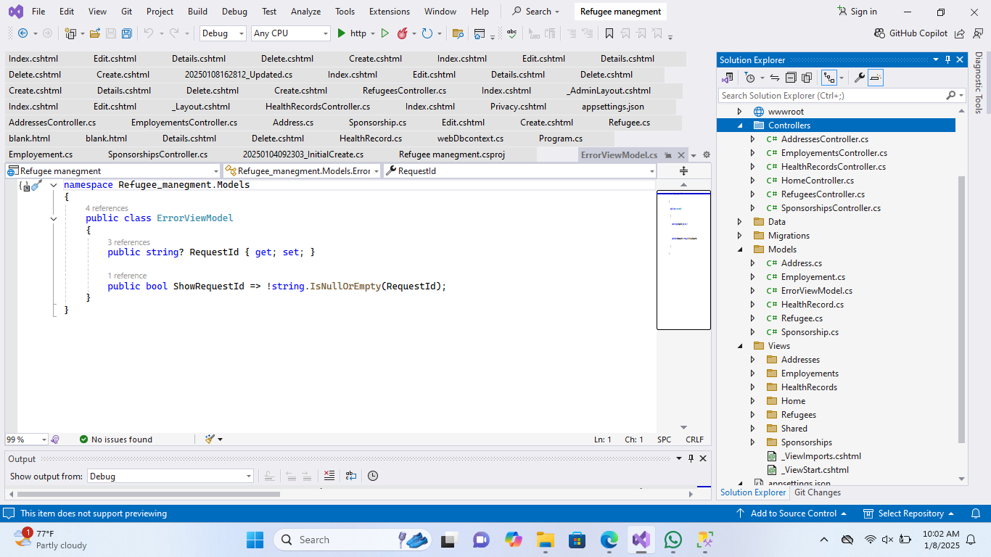

. It seems like you've uploaded a screenshot of your Visual Studio project. Based on the image, you already have a structure in place with models (Address, Employment, HealthyRecord, Refugee, and Sponsorship) and controllers corresponding to those models.

If you'd like me to assist with creating or enhancing a specific part of your project (like the Index page, Edit page, or any other feature),

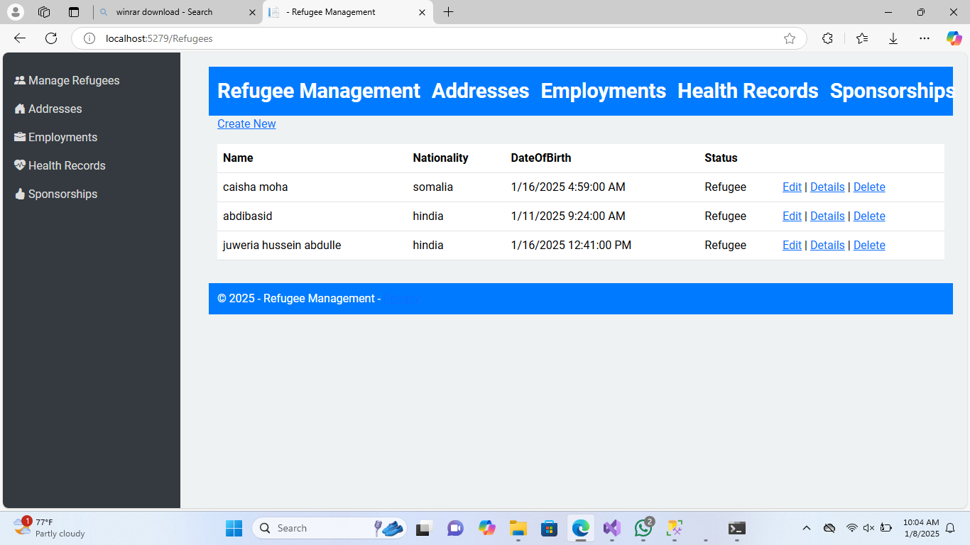   
The **Refugee Management** page allows you to efficiently manage refugee information, including their name, nationality, and status. You can easily update their data (Edit), view detailed information (Details), or remove entries (Delete). The system is user-friendly and streamlined for effective use.

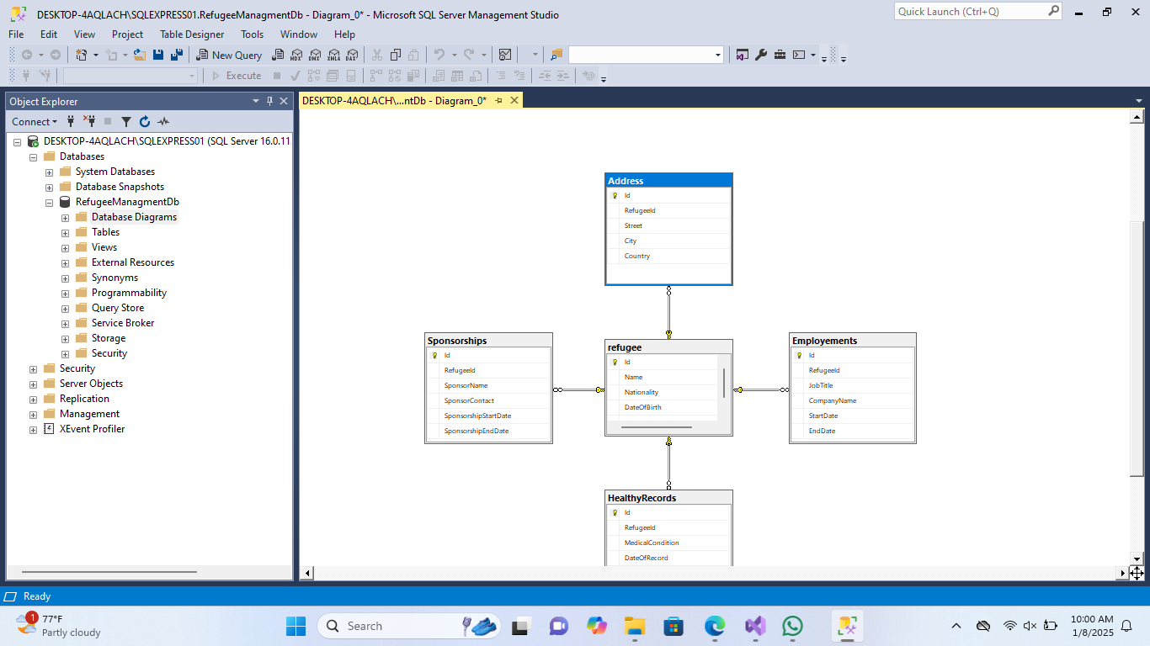

**Relationships between the tables:**

* **Refugee** acts as the central table:
  + **Address** is linked to the **Refugee** table through the RefugeeId column.
  + **Sponsorships** is connected to **Refugee** through the RefugeeId column.
  + **Employments** is linked to **Refugee** using the RefugeeId column.
  + **HealthyRecords** is associated with **Refugee** via the RefugeeId column.

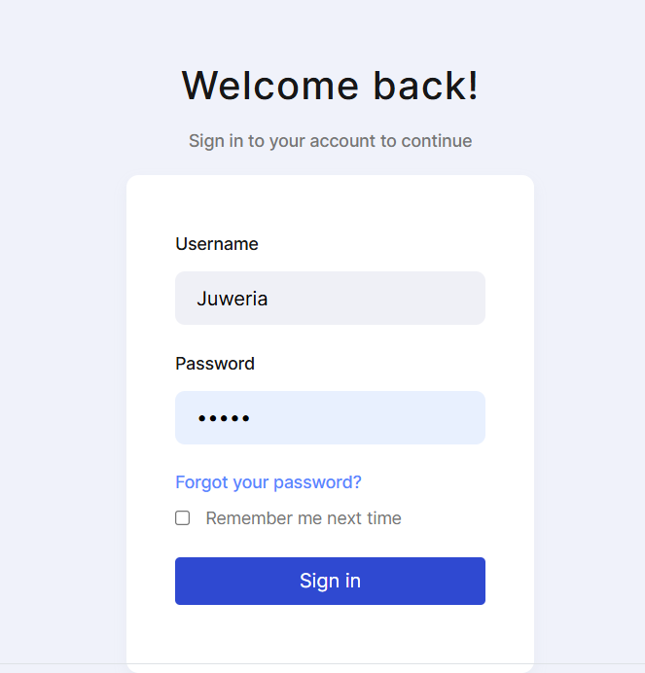. this is my login page